**KEY AREA: TRANSFORMING TEACHING LEARNING PROCESS**

**UNIT: SCHOOL AND PURPOSE OF EDUCATION**

**MODULE NAME: Education for Life Skill**

**What is school?**

The normal meaning of school is a place where education is provided to the students. Most of the countries have system of formal education which is compulsory. In these systems, the student goes through a series of schools like primary, middle, secondary and senior secondary. In the schools, the students are expected to get education that will help them to sustain their life.

**Education**

What is the purpose of education? Why do we need to go to school? Questions like these are ones that are need to be asked to oneself.

Education is a social process by which skills, beliefs, attitudes and ideas are learned. The achievement and development of an education can help one succeed in society.

We find that two students can go through the same education system, and one come out as a successful person, while the other can become what society would call a failure.

But, success does not mean getting a first or second class degree. The real success is that the person is able to sustain his life in a comfortable way. Therefore, the aim and purpose of school and education system should be to make a student able to lead a comfortable life.

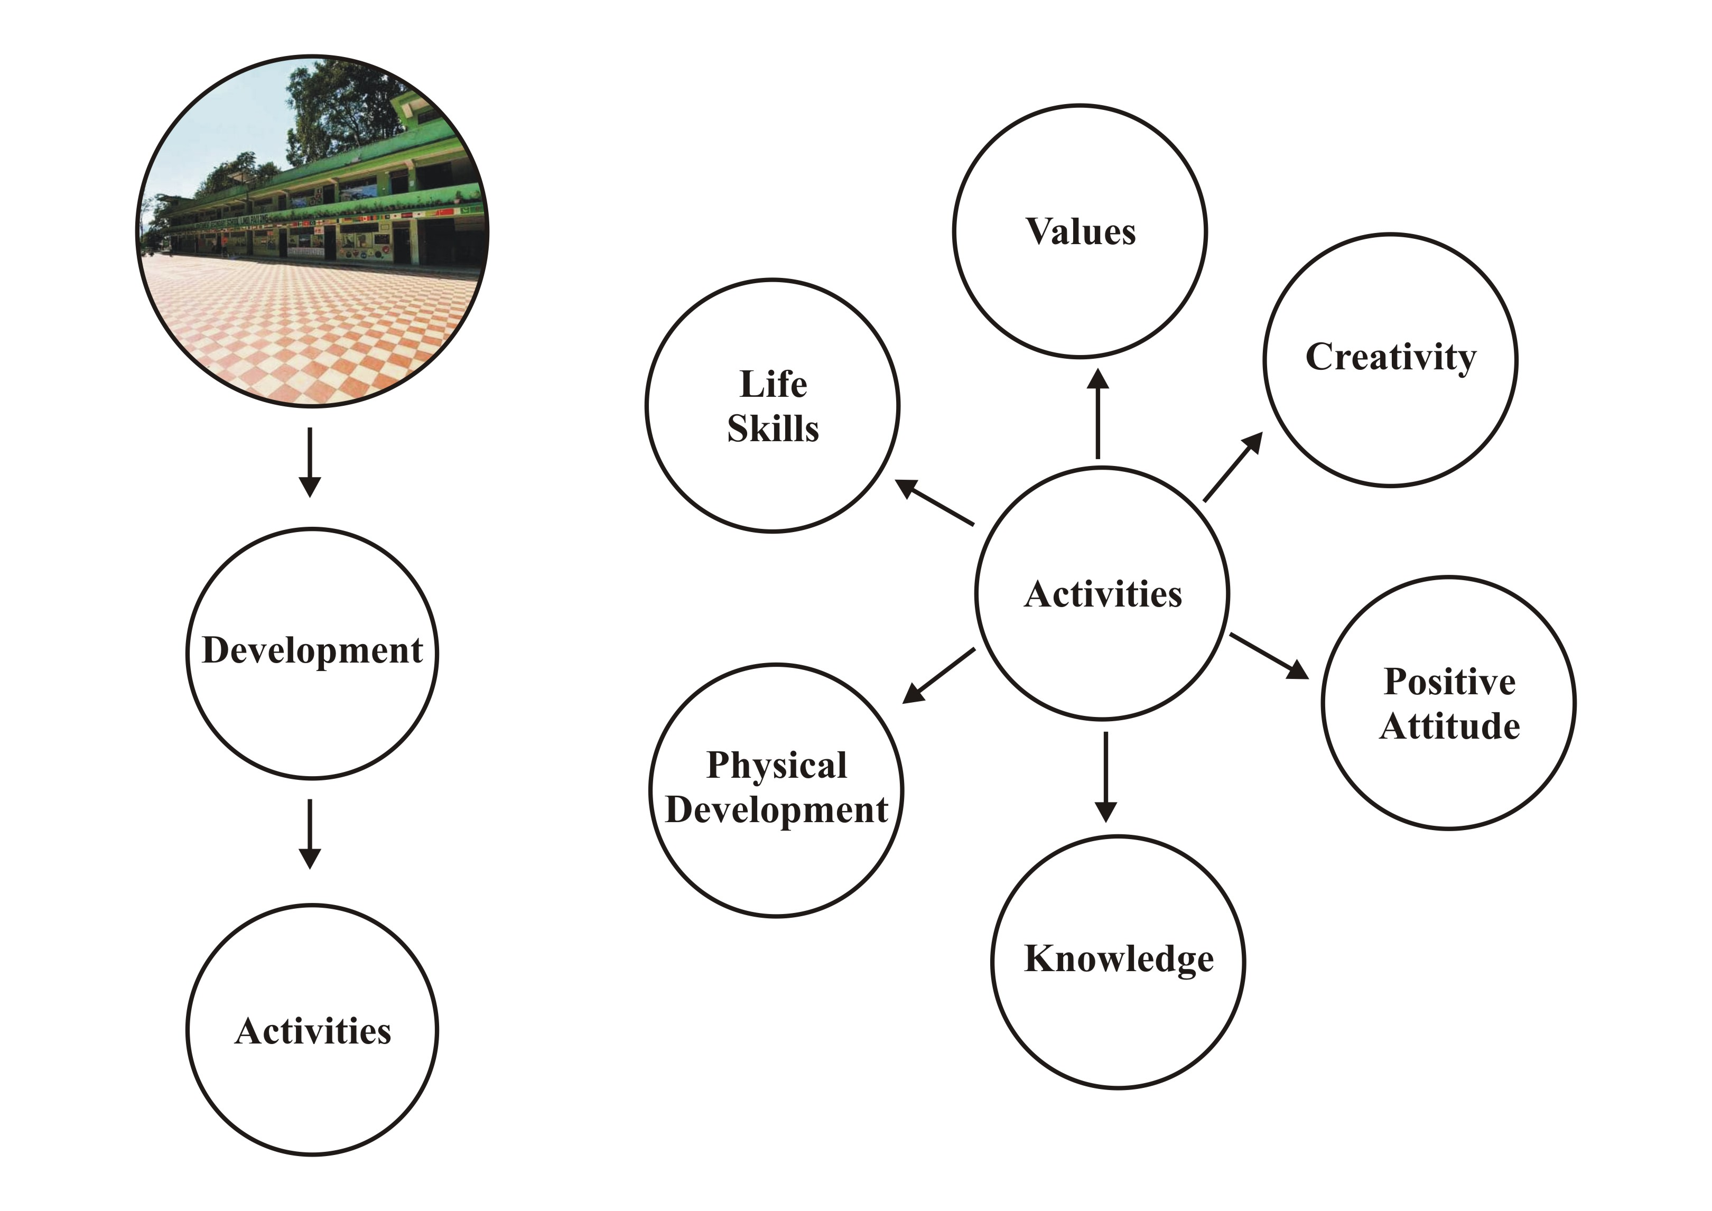

Keeping in views the different purposes of school and education, schools in our state are doing every bit to impart the best possible skills and knowledge to let them live a successful life. The schools have been providing knowledge of life skills, positive attitude, value education, creative skills beside knowledge on various subjects.

**TITLE:**

***Life Skill as a part of education to equip oneself with alternative skill to earn livelihood***

**LEARNING OBJECTIVE:**

The module enables the learner to understand the importance of life skill knowledge and acquire it through collaboration. This will equip them with basic skills of alternate livelihood.

**KEYWORDS:**

Life Skill, Collaboration, Participation, Creativity, Alternative Livelihood

**INTRODUCTION:**

Life skill knowledge is provided to the students in the schools of Sikkim through periodic activities organized with the help of teachers, local artisans and craftsmen. With the introduction of vocational education in secondary and senior secondary level, various such skills are imparted to the students.

Life skill education is being imparted as vocational education in the schools of Sikkim from 2004. With avenues to the government jobs in the state having reached saturation situation, the professional training and vocational education in school would give children the skills to find “Self Employment”. The National Policy of Education, 1986 has laid down great emphasis on imparting vocational education at the senior secondary level.

The objectives of vocational education are primarily aimed towards aiming our students with the right knowledge and practical skills; to prepare students for gainful self/wage employment and diversification of education and opportunities; reduce the mismatch between demand and supply of skilled and semi skilled manpower and to provide an alternative for those pursuing his or her education without any definite purpose.

**CORE CONTENT**

**Government Senior Secondary School Jorethang South Sikkim**

Government Senior Secondary School Jorethang South Sikkim started work on carpentry development in school since a couple of years ago. The activity is directly related to Gandhi’s experiential learning, which is included in Wardha Scheme of Education 1939, also called Gandhi’s Basic Education. Craft is also a part of curriculum which adheres learn as well as earn. Students are occupied with useful carpentry work with the support of teachers. They prepared their own bookshelf for the classroom. Though it is a small activity but along with study in schools can be considered as creativity of students. According to Gandhi, this is called experiential cum joyful learning in this context.

**Sonam Choda Lepcha Memorial Secondary School, Lingdong, North Sikkim**

The activity related to craft which is more meaningful and involve school children of different levels by Sonam Choda Lepcha Memorial Secondary School prepared items called Cushion made from “Best out of Waste”. Active participation and collaboration with each other by the students followed the Gandhi’s craft centred education (1939). Education in the form of learning by doing is an example of joyful learning in schools. Such a craft collaboratively prepared has a value and a productive work for the community. The immense value of productive work is active and joyful learning.

The link to access the video showing the activities of above two schools can be viewed in youtube through the link:

<http://youtu.be/4U4yt4lz-Qs>

The basic idea of Wardha Scheme is to impart education through some craft or productive work. Craft work helps the child to acquire sensor and motor coordination and to appreciate the value of honest labour. Gandhiji believed that the method of training the mind through village handicraft from the beginning as the central focus would promote the real, disciplined development of the mind. The advantages of making craft as the center as listed by Zakir Hussain Committee as under:

Psychologically, a pure academic and theoretical instruction against which is active nature us always making a healthy protest. Secondly, tend to break down the existing barriers of prejudice between manual and intellectual workers harmful alike for both. Economically, carried out intelligently and efficiently the scheme will increase the production capacity of our workers and will also enable them to utilize their leisure advantageously. From educational point of view, great concreteness and reality can be given to the knowledge acquired by children through craft as knowledge will be related to life. Self supporting aspect of the scheme may be defined in two ways:

1. Education that will help one to be self supporting in later life
2. Education which in itself is self supporting

**Activity**

1. Government Senior Secondary School Ranka practices paper waste management through various activities.

**Boat/Aeroplanes**

**Wall Hangings**

**Flower Vase**

**First Aid Box**

As per the school’s convenient, create other situations to prepare some joyful activities for the children to make teaching learning more effective and productive so that during any functions, school may sell those items to the community/teachers/guests for school fund.

1. Lots of locally available materials are found scattered in school campus and community. Collect and prepare activity according to the needs of the children.

**BOTTLES AND PLASTIC REUSE MANAGEMENT**

**CRAFT 1**

**CRAFT 1**

**CRAFT 1**

**CRAFT 1**

**Let Us Sum Up**

According to Gandhian Philosophy, the productive work in schools based on Nai Talim is a principle which states that knowledge and work are not separate. Mahatma Gandhi also promoted an educational curriculum with the name based on this pedagogical principle. It can be translated with the phrase “Basic Education for all”. However, the concept of several layers of the meaning. The real difficulty is that people have no idea of what education truly is. We assess the value of education in the same manner as we assess the value of land or of shares in the stock exchange market. We want to provide only such education as would enable the student to earn more. We hardly give any thought to the improvement of the character of the educated. The girls, we say, do not have to earn, so why should they be educated? As long as such ideas persist, there is no hope of our ever knowing the true value of education. The idea behind is why not to utilize Gandhian ideas to contextualize the pattern of education here in Sikkim.

In Wardha Scheme of Education, Gandhi stated that given Gandhi’s values and his vision of what constituted a truly civilized and free India, it was not surprising that the developed form views on education. This means education not only moulds the new generation but reflects a society’s fundamental assumptions about itself and the individuals which compose it. The purpose of school education would be fulfilled by the above cited ideas.

**References**

Burkey, B. (2000). Mahatma Gandhi on Education, The Encyclopedia of Pedagogy and Informal Education. (<https://infed.org/mobi/mahatmagandhi-on-education/> retrieved on 5th May 2020.

[www.sikkimhrdd.org.in](http://www.sikkimhrdd.org.in) (Official website of Education Department Government of Sikkim) retrieved on 07th May 2020.

**Assessment for the Module**

1. According to the video prepared by Govt. SSS Jorethang signifies that
2. Collaborating
3. Participating
4. Low Cost Materials
5. All the above
6. Cushion is prepared by remote school of Dzongu, North Sikkim helps the children to a) Earn

b) Time Waste

c) Dirtying surroundings

d) None of the above

1. The then scenario of Gandhi’s education is different from present scenario in
2. Methods
3. System
4. Principles
5. Implementation
6. Present curriculum of school education based on
7. Programme of Action 1992
8. New Education Policy 1986
9. Secondary Education Commission 1952
10. New Education Policy 2019
11. The **most common** activity in the schools of Sikkim is
12. Research Projects
13. Field Survey
14. Symposium and Seminar
15. Assembly Speech

**Additional Reading**

1. Mahadev Desai, (2009), M K Gandhi: An autobiography or The story of my experiment with truth. Gandhi Hindustani Sahitya Sabha, Rajghat, New Delhi 110002. ISBN: 978-81-86198-476
2. J. C. Agarwal (1992). Education in the contemporary world. APH Publishing House New Delhi, 110001
3. Dewan, D.B. (2012). An introduction to Education history in Sikkim from pre to post merger. Tender buds Academy Publication, Pedong, Kalimpong, West Bengal.

Submitted By

1. Mr. Manorath Dahal

Assistant Professor

SCERT Sikkim

E-mail: [mahalangurdahal@gmail.com](mailto:mahalangurdahal@gmail.com)

Ph: 9434384570/8509788747

1. Mr. Suraj Kumar Sharma

Headmaster

Govt. Sec. School Lingi Payong South Sikkim

E-mail: [gautamsuraj1981@gmail.com](mailto:gautamsuraj1981@gmail.com)

Ph: 7551835194/7001121284